**SCHOOL OF QUANTITATIVE SCIENCES**

**COLLEGE OF ARTS AND SCIENCES**

**SQIT3073 BUSINESS ANALYTICS PROGRAMMING**

**GROUP A**

**FIRST SEMESTER SESSION 2023/2024 (A231)**

**GROUP ASSIGNMENT 1**

**SUBMITTED BY:**

|  |  |
| --- | --- |
| **NAME** | **MATRIC NUMBER** |
| **BEH HUA EIK** | **279018** |
| **LEE JIAN YUAN** | **281705** |

**SUBMITTED TO: DR. MOHD AAMIR ADEEB BIN ABDUL RAHIM**

**SUBMISSION DATE: 16TH DECEMBER 2023**

**TABLE OF CONTENTS**

|  |  |  |
| --- | --- | --- |
| **NO.** | **CHAPTER** | **PAGE** |
| 1.0 | INTRODUCTION | 1 |
| 2.0 | OBJECTIVES | 2 |
| 3.0 | METHODOLOGY | 3 – 4 |
| 4.0 | RESULTS AND DISCUSSION | 5 – 8 |
| 5.0 | CONCLUSION | 9 |
|  | APPENDIX | I |

1. **INTRODUCTION**

Financial domain which impacting the world economy and is related to the daily life of every human being on Earth is complicated as it is dynamic and ever-growing. In Malaysia, the Monthly Highlights and Statistics (MHS) publications published by Bank Negara Malaysia (BNM) is a very crucial resource and database for citizens to understand the economic condition of nation. This assignment delves into the extraction, analysis, and visualization of data from BNM with the aim to discover the patterns of data and unravel valuable insights for future decisions.

As a decision science student, we aim to use Python programming language and web scraping techniques to access the latest MHS data from the official BNM website. The data collected will then be transformed into a structured format data using pandas, a powerful data manipulation library. Furthermore, Matplotlib, a widely used data visualization library in Python, will be leveraged to generate insightful charts that encapsulate key trends and patterns within the extracted data.

Our expectation for this study includes two explore direction. First, serve as a technical exploration on using Python. Secondly, which is the essence of this study, seeks to foster a deeper understanding on how the data in Monthly Highlights and Statistics shape our country’s economy. The following sections of this report will state the objectives of this study, provide a detailed overview of our methodology, present the results in a comprehensible manner through charts and critical analysis, and conclude with key takeaways and potential avenues for further investigation. Through this endeavour, we aim to showcase the potential of crossover of financial acumen and technological prowess in unlocking the stories behind the MHS data.

1. **OBJECTIVES**

The objective for this report is as follows:

1. To analyse Malaysia’s quarterly GDP growth rates from 2016 to 2023 and identify trends, spikes or declines in economic growth.
2. To assess sector-wise contributions to Malaysia’s GDP and highlight the sectors that have been great growth drivers.
3. To identify specific policies or global events that may impact Malaysia’s economic performance.
4. **METHODOLOGY**

**Data Collection**

The data used in this assignment is sourced from the publications of the Central Bank of Malaysia (BNM) titled Monthly Highlights and Statistics (MHS) last updated in October 2023. Every month, BNM updates their existing list of datasets that cover Malaysia’s monetary system which includes data for rates, banking data, capital markets, macroeconomic indicators and many more. For the purpose of our assignments which covers GDP analysis, the data is retrieved from 2 datasets which are 3.3: Gross Domestic Product by Expenditure Components at Constant 2015 Prices (Annual Change) and 3.4.1: Gross Domestic Product by Kind of Economic Activity at Constant 2015 Prices.

Dataset 3.3: Gross Domestic Product by Expenditure Components at Constant 2015 Prices (Annual Change) contains yearly and quarterly GDP information where the annual change or the % of change year over year (YoY) is provided. These data are after adjustment to account for inflation or changes in price levels by reporting them at constant 2015 prices which will allow a more accurate comparison of Malaysia’s economic performance over time.

On the other hand, dataset 3.4.1: Gross Domestic Product by Kind of Economic Activity at Constant 2015 Prices contains the breakdown of yearly GDP by various economic activities. Like 3.3, the GDP values are adjusted to constant 2015 prices to account for inflation or changes in price levels over time to allow for a more accurate comparison of economic output.

**Data Preprocessing and Transformation**

Before any preprocessing and transformation, the 2 required datasets are downloaded from BNM’s open website. These datasets which are in the excel worksheet format (.xlsx) are then pre-processed and transformed using Microsoft Excel where data is manually extracted and formatted in a standard manner.

**Visualisation and Analysis**

To create visualisations to represent the data for analysis, Matplotlib in Python is used to generate charts such as line charts and stacked area charts to depict GDP trends and contributions by economic activity. These charts will then be interpreted and analysed to extract valuable insights.

**Flow Chart**

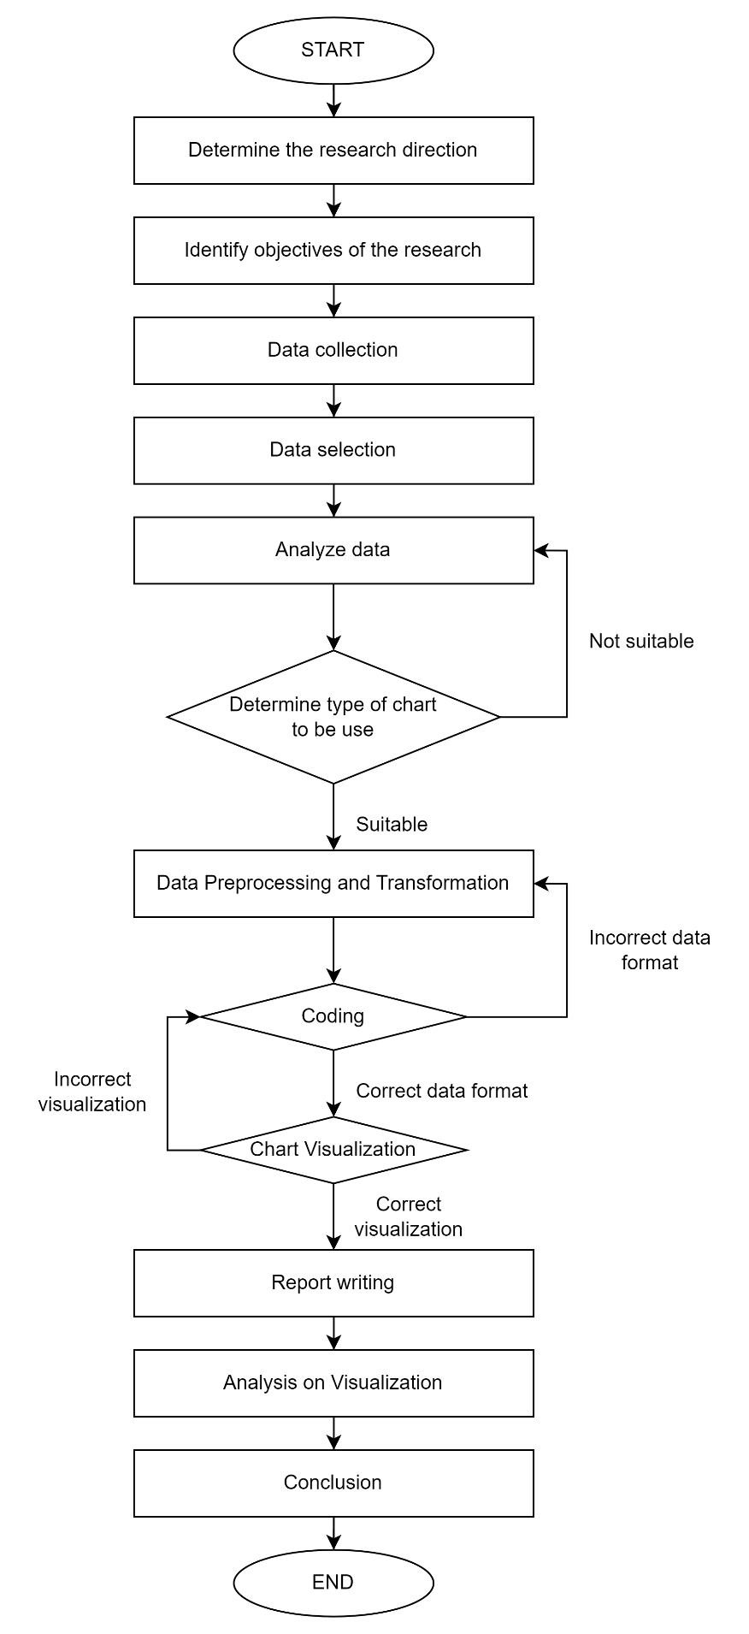

1. **RESULTS AND DISCUSSIONS**

**Analysis 1**

**Chart 4.1**

**Overall Trend**

The chart shows Malaysia’s quarterly year-over-year (YoY) GDP growth rate for the period from Q1 2016 to Q3 2023. We see considerable fluctuation in growth rates over this period, with both positive and negative growth.

**2016-2019 Period**

From 2016 through 2019, GDP growth remained positive, ranging between around 3.6% to 6.15%. Growth peaked in Q3 2017 at 6.15%. The economy appeared relatively strong and stable during this period aside from some mild fluctuation in growth rates quarter to quarter.

**2020 Period**

In early 2020, growth barely remained positive but started decelerating. Then in Q2 2020, at the onset of the COVID-19 pandemic, growth turned sharply negative, with the GDP growth rate hitting -16.93%, indicating a severe economic contraction. This is by far the lowest and most negative growth rate shown during the entire period. Majority of this economic contraction was brought about by the Movement Control Order (MCO), a national quarantine measure meant to curb the spread of the COVID-19 disease. As the global pandemic began at that time, strict measures during the initial stages of MCO meant that a large portion of industries were instructed to close.

In Q3 and Q4 of 2020, negative growth continued but was less severe at around -2.5% to -3.2%. This signals the economy was still struggling and contracting, just not at the same disastrous rate as earlier in 2020. This was in line with the loosened restrictions of the Malaysian Government to allow the nation to recover from the pandemic.

**2021-2023 Period**

Growth rebounded back into positive territory in 2021 and has remained positive since, indicating the economy has been in recovery and expansion mode since the pandemic contraction of 2020.

However, we still see considerable fluctuation and uncertainty in growth rates post-pandemic. Growth jumped back up to over 16% in Q1 2021 but then was very volatile quarter to quarter after that, ranging from strong growth around 8-14% to weaker growth around 0-4%. Notably, the negative growth of -4.22% in Q3 2021 should be mentioned as a major contributor to the volatility of the post-pandemic economic recovery period. This can be directly linked to Full Control Movement Order (FMCO) which began at the end of May 2021 where Malaysia went back to a strict quarantine measure to slow down COVID-19 cases. This measure essentially took place the entire third quarter of 2021 with restrictions loosening up after mid-September.

Since then, GDP growth has been steadily positive. 2022 has seen a steady increase in growth as the economy was recovering post-pandemic before slowing down a little at 7.11% in Q4.

In 2023, growth slowed down to 2.85% in Q2 before growing to 3.3% for the third quarter, likely indicating cooling economic expansion as the post-pandemic recovery period continues to normalise. But volatility persists.

**Key Takeaway**

The key takeaway from the chart is the considerable volatility in GDP growth post-pandemic, reflecting an uncertain economic environment. The economy contracted severely in 2020 before rebounding, but sustaining consistent solid growth has remained elusive quarter to quarter. Continued fluctuations are expected as the post-COVID recovery and new normal continues to play out.

**Analysis 2**

**Chart 4.2**

Chart 4.2 above is a stacked area chart that visualizes the record of past Gross Domestic Product (GDP) by kind of economic activity. The x-axis of the chart labels the period (year) from 2015 to 2022, the y-axis of the chart labels the GDP level in RM million, and the GDP by each kind of economy activity is categorize by a different colour.

**Primary Sector**

From the chart, we can first conclude that Malaysia’s economy in the primary sector which includes agriculture and mining and quarrying has almost reached a point of stagnation, showing no further signs of expansion or contraction over the years. As evidence, the two sector does not show any sign of fluctuation even when of COVID-19 pandemic hits Malaysia in year 2020.

**Secondary Sector**

Then, regarding Malaysia’s secondary economic sector which consists of manufacturing and construction, both sectors have been slowly but stably expanding over the years before the complete outbreak of COVID-19 pandemic hit Malaysia in the year 2020. The effect of the pandemic is crucial especially in the construction sector as this sector still hasn’t recovered and returned to its peak up till now. On the other hand, although the manufacturing sector also suffered from the pandemic in year 2020, it quickly recovered from it and regained its peak in the next year.

**Tertiary Sector**

Lastly, the tertiary economic sector which encompasses all service sectors in Malaysia has shown robust growth annually, particularly witnessing a notable surge in the year 2022. As the major income contributor to maintain Malaysia's economic stability, the tertiary sector consistently contributes more than 50% of the overall GDP each year. The resilience of this sector, however, faced a temporary recession in 2020 amid the outbreak of the COVID-19 pandemic. Other than its economic significance, the rapid growth of the tertiary sector plays a pivotal role in creating substantial job opportunities for Malaysia’s citizens, highlighting its crucial role in the country's economic landscape as a high unemployment rate in a country would cause low productivity and brings to recession of an economy.

**Key Takeaway**

The three signs above are considerably good because an economy tends to focus more on secondary and tertiary industries as it becomes more developed. Not to mention, all these data haven’t been able to reflect the after-effect of the release of ChatGPT on 30 November 2022. The release of ChatGPT has not only changed the world thoroughly but also lowered the threshold of self-media to a level where everyone in the public can actively participate in the burgeoning digital economy. This global change enables individuals to be self-employed or create secondary income, marking the onset of an AI-driven era that reshapes roles in work and entrepreneurship as everyone is free to harness the power of artificial intelligence (AI) nowadays. Lastly, as AI becomes increasingly accessible, Malaysia’s economy now stands at the forefront of a new era with uncountable opportunities for the tertiary sector to leverage technological advancements and ensure sustained growth, thereby securing a dynamic and resilient economic future for the country.

1. **CONCLUSION**

Chart 4.1 that visualizes Malaysia's quarterly year-over-year Gross Domestic Product (GDP) growth rate from Q1 2016 to Q3 2023 reveals a tumultuous economic landscape marked by significant fluctuations. The period from 2016 to 2019 demonstrated positive and stable growth, while the outbreak of COVID-19 pandemic in 2020 led to a severe economic contraction. In the following years, the economy is recovering, together with notable volatility, indicating the challenges of navigating the post-pandemic economic landscape.

Then, Chart 4.2 that visualizes Malaysia's GDP by sector shows that the primary sector, including agriculture and mining and quarrying is in stagnant condition, showing resilience even during the COVID-19 pandemic. As for secondary sector, including manufacturing and construction, experienced a slow but steady expansion before facing recession in year 2020 due to COVID-19 pandemic and construction sector is yet to fully recover. In contrast, the tertiary sector which include all the service industries, demonstrated a robust growth, constituting a vital component of Malaysia's GDP, and offering substantial job opportunities.

In conclusion, Malaysia's economic journey reflects resilience together with challenges, and is recovering from the COVID-19 pandemic underway. The interplay of global events, technological advancements, and sectoral dynamics underscores the need for adaptability and strategic planning as Malaysia navigates the complexities of a post-pandemic and AI-driven landscape.

**APPENDIX**

**GitHub Link:**